

User Manual

Venn Project

Version 5.0

Group 19

Table of Contents

Opening and Running the JAR File: 3

Main Scene: 3

Add Data: 4

Editor: 5

Change Color: 5

Change Size: 6

Add Label: 7

Edit Text: 8

Description: 9

Undo/Redo: 10

Clear All: 10

Add Data Scene: 11

enter explicitly: 11

Explicit Data entry: 12

compute from two sets: 13

Data entry: 14

Done: 15

VennTest: 16

Open/Save/Export: 17

Help: 18

# Opening and Running the JAR File:

1. First, download the Runnable Jar file and locate it in your files
2. In the ideal situation, you should be able to double-click on the JAR file to be able to run it (MacOS users should be able to run in this way)
3. If not, open your Terminal/Command Prompt and enter the directory in which the JAR is located
4. Now type **java -jar _____ file name** and click enter, the App should now appear in a separate window on your screen

# Main Scene:

The main window will look like:

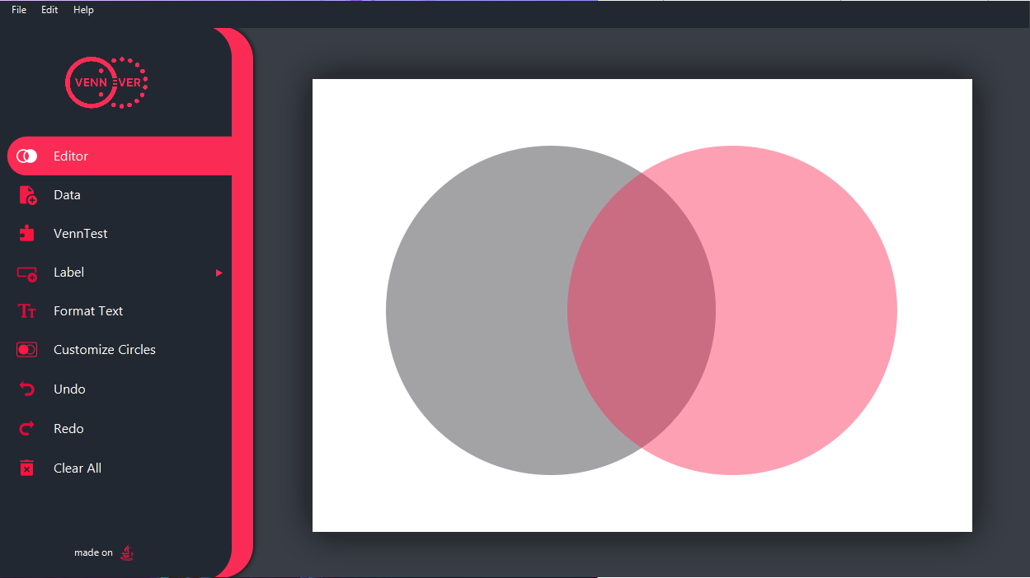

Figure

## Add Data:

* Press button “Data” to go to the next scene to add elements into your sets. (refer to the Add Data Scene section for further instructions on how to add elements to your diagram)



Figure

* Once you click on “Data”, below is how your window should look (click on “Editor” to go back to the previous view of the main scene)

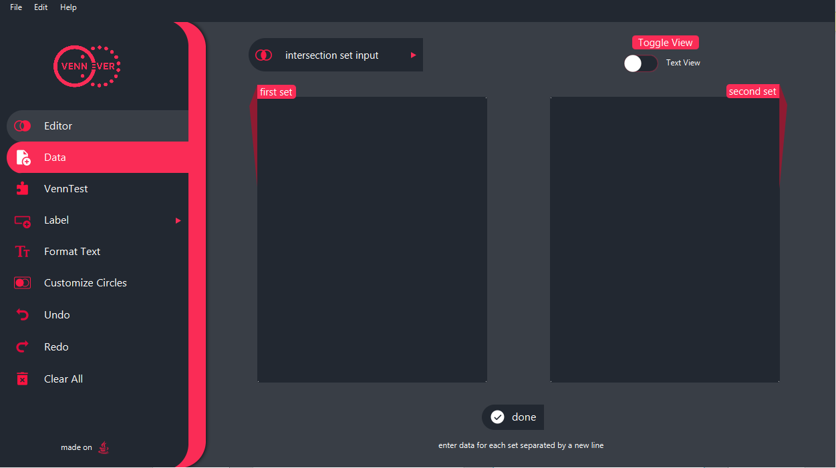

Figure

## Editor:

### Change Color:

* + - Click on the circles or click “Customize Circles” on the left toolbar on your window to toggle the edit circle toolbar (re-click to minimize the toolbar)
    - A toolbar will appear on the top of your application window
    - you may choose either the left or right circle and click on their respective drop-down color palettes to choose your custom color
    - Figures 4 and 5 provide a visual of the above steps for further explanation

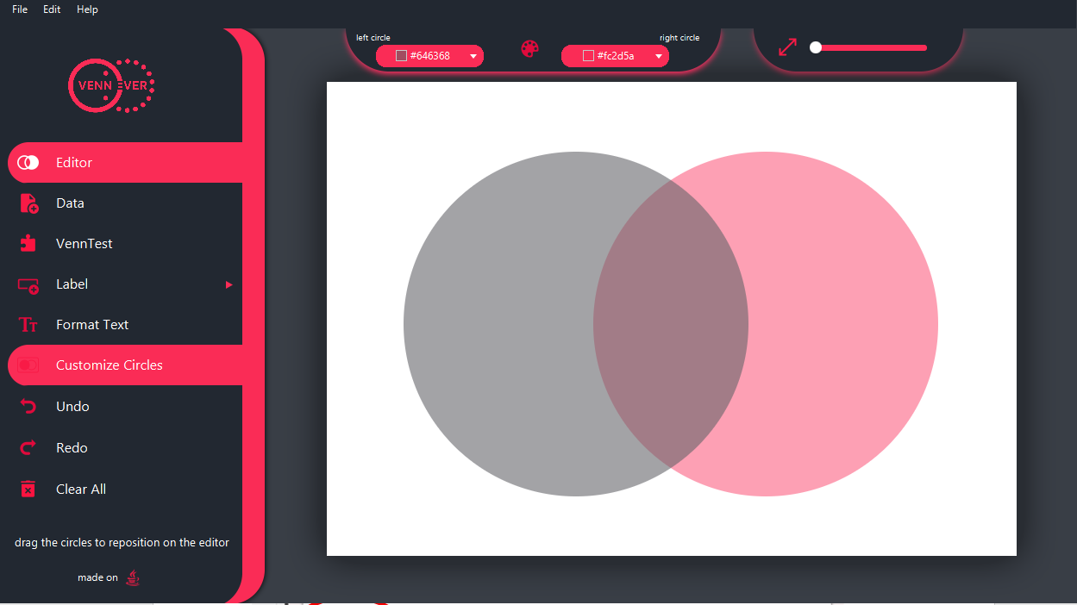

### 

Figure

### 

### 

Figure

### Change Size:

* Click on the circles or “Customize Circles” button to toggle the edit circle toolbar
* Drag the slider to the right to increase the size of both circles
* Drag the slider to the left to decrease the size of both circles

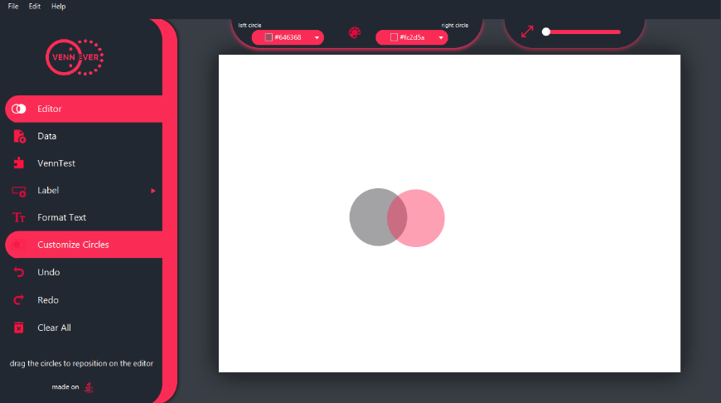

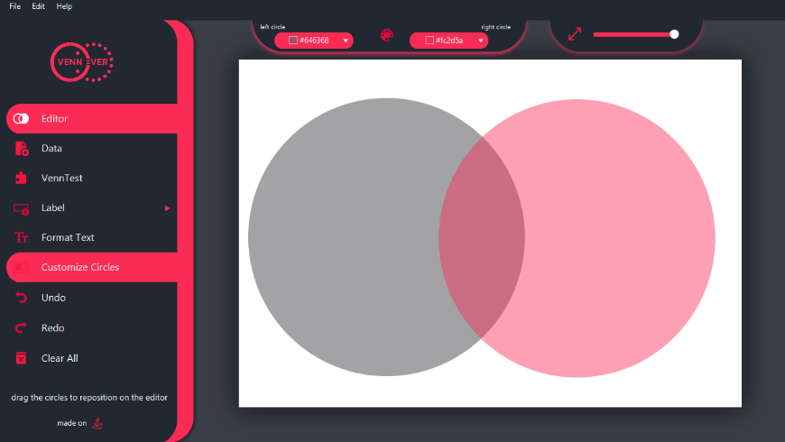

Figure

Figure

### Add Label:

* + Press the Button “Label “
  + A menu will appear, and you can choose the type of label you want to add to your diagram. Click on the type of desired label
  + An editable textbox will appear on the window
  + Click on the created text box to edit the text
  + Click and drag with mouse/trackpad to move the text box around
  + Release mouse click to drop dragged text box in its desired location

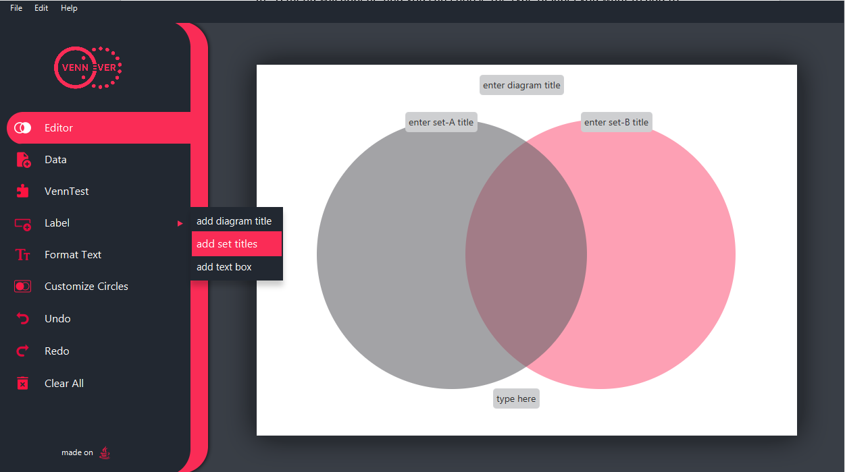

Figure 6

Figure : please note that the color-coded arrows relate the buttons to what appears on the window once clicked respectively.

### Edit Text:

* Click on desired textbox to edit or press “ctrl” (or cmd if using a mac) and select multiple textboxes to edit
* A toolbar will appear at the top of the window with text edit options
* 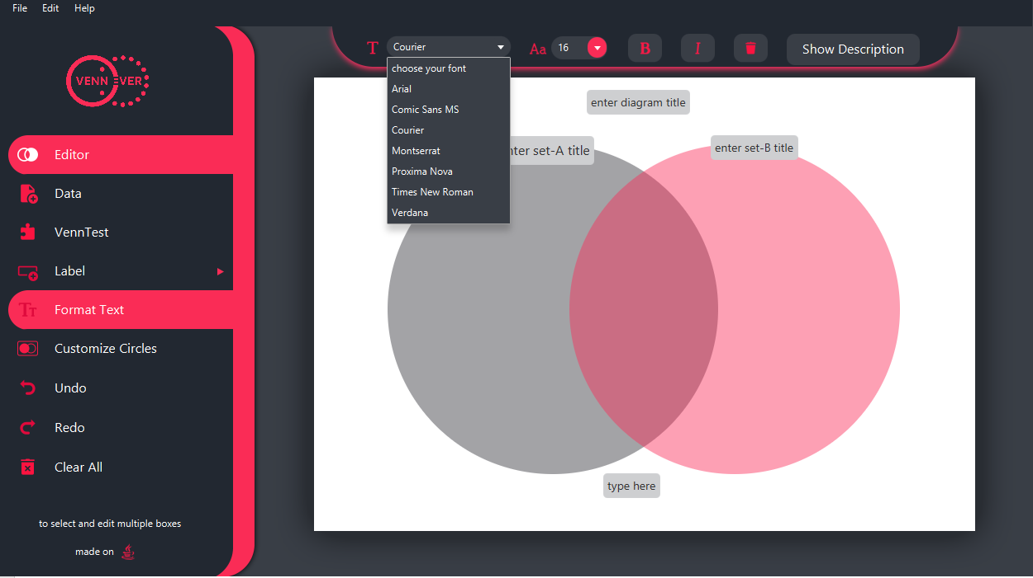You may change font, choose a different text size, bold or italic and delete the text box from this toolbar

Figure

### Description:

* You have an additional option to further describe an element of a given set
* Click on a textbox or multiple textboxes by holding on the “ctrl” key or “cmd” key if you are using a mac
* The edit text toolbar will appear at the top of your window
* Click on “Show Description”
* A text field will appear on the page, enter your additional information and click “ok” when finished

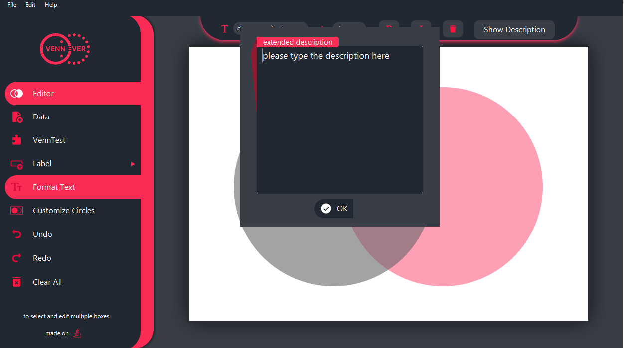

Figure

## Undo/Redo:

* After making any of the above changes to the Venn diagram click on Undo to go back to the Venn diagrams previous state
* To revert the undo and re-do the change that was undone click on /Redo

Figure

## Clear All:

* 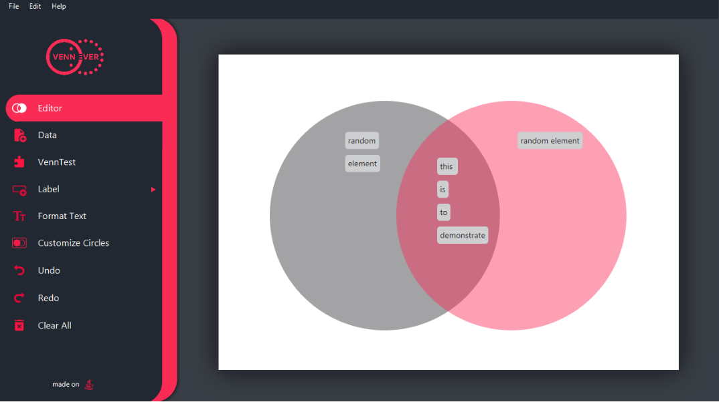To clear your Venn diagram, click on “Clear All” on the left toolbar

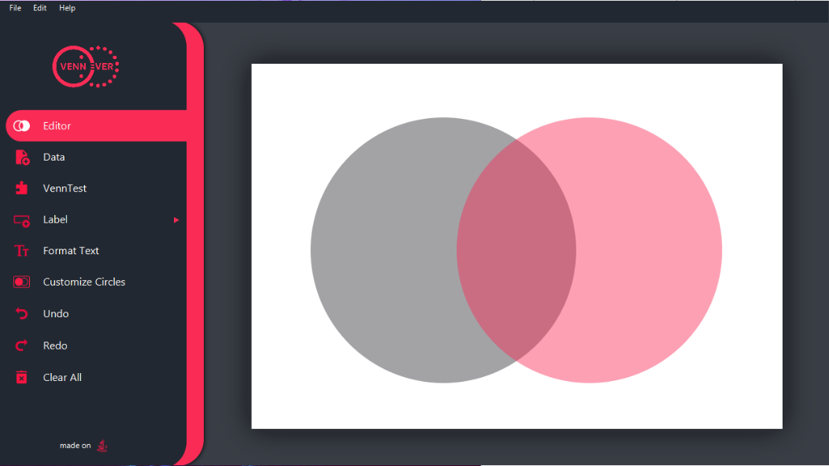

Figure : before pressing “Clear All”

Figure : after pressing “Clear All”

# Add Data Scene:

Pick your preferred method of entering in the data

## enter explicitly:

* Choosing this option will allow you to enter the “intersection set” separately along with the first and second sets of data

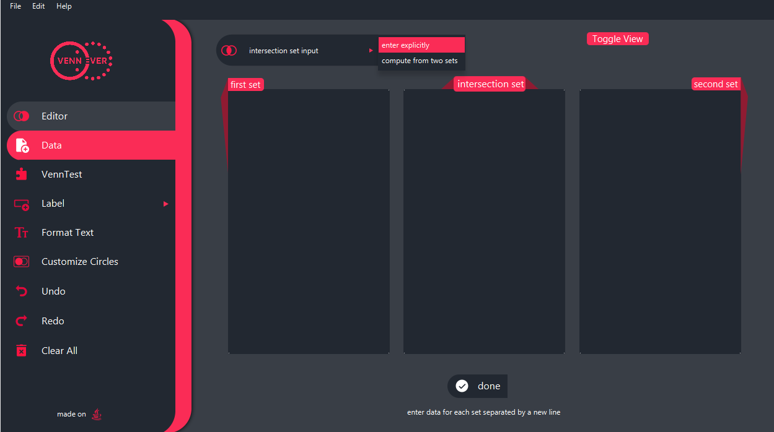

Figure

### Explicit Data entry:

* Click on the “enter explicitly” button and enter your data into the textbox labeled “Intersection set”
* Click “done” when you are finished
* Figure 16 demonstrates how the text will appear on the diagram
* Click on any textbox to edit its text contents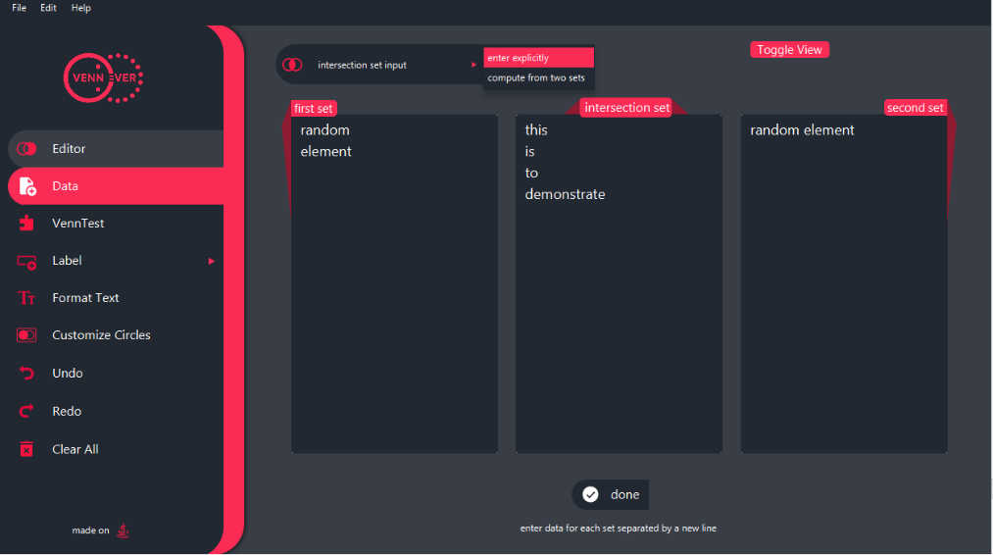



Figure

Figure

## compute from two sets:

* 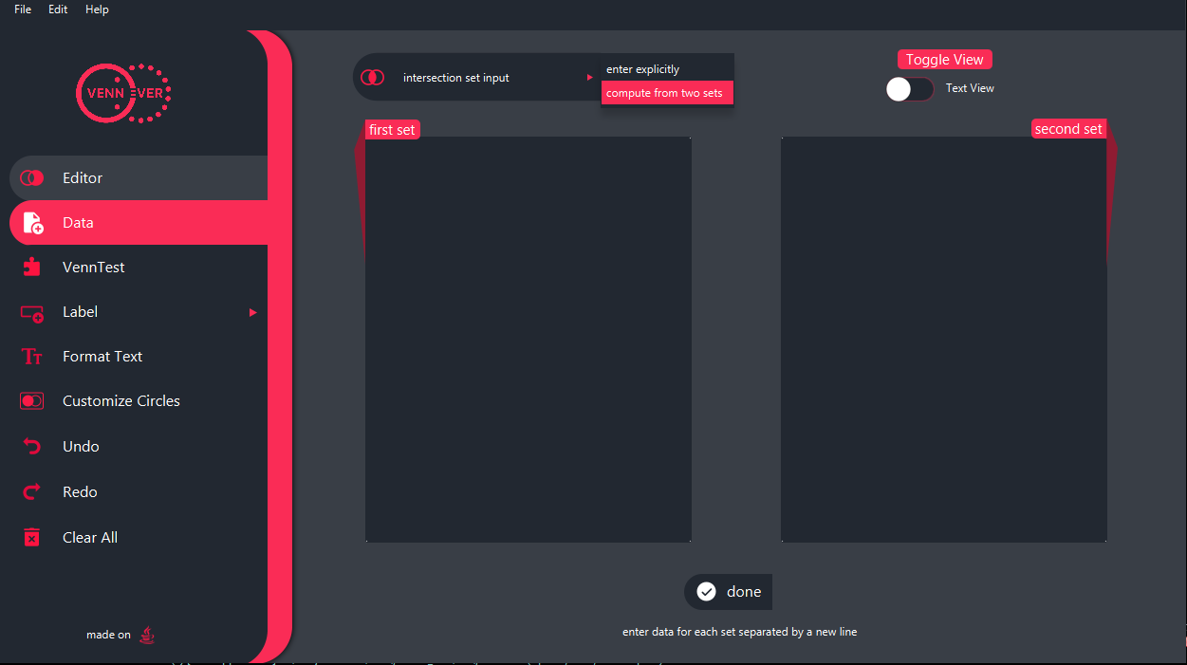Choosing this option will have the application compute the intersection set for you from data you enter into the sets

Figure

### Data entry:

* + Enter text into the “first set” or “second set” line by line (text in one textbox would be on one line, text in a separate text box would be on a different line)
  + The application will compute based on your input and automatically fill the intersection set with the appropriate data
  + Figure 19 demonstrates how the text will appear on the diagram

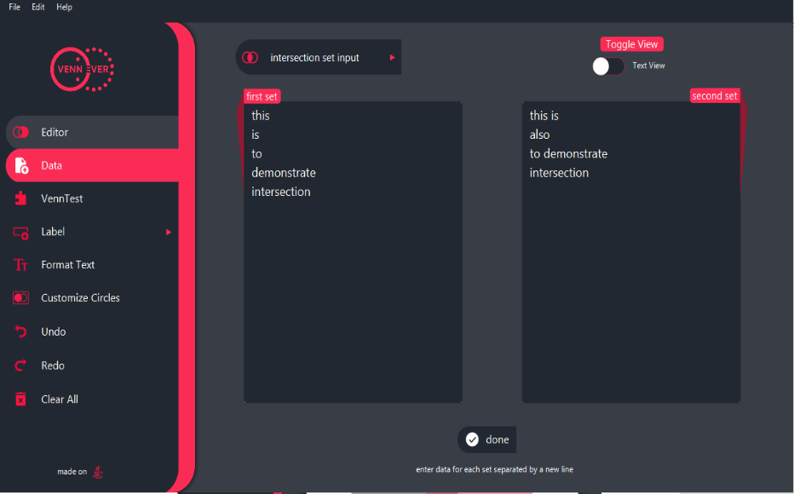

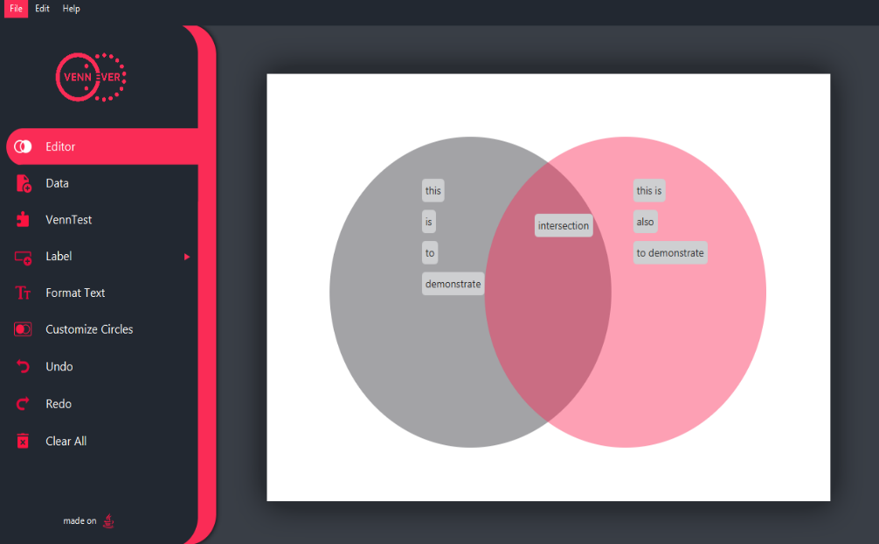

Figure

Figure

## Done:

* Click “done” once data is entered into the above boxes
* done will take you back to previous scene

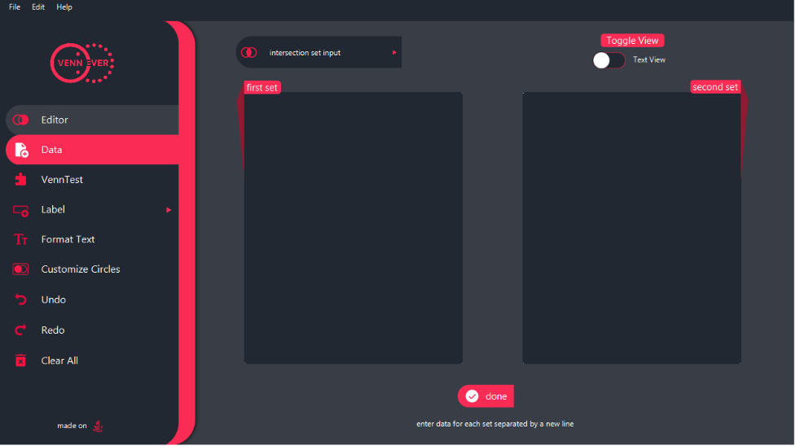

Figure

# VennTest:

* Click on VennTest from the left toolbar
* follow the instructions on the “VennTest” feature that will appear on your screen
* Click “ok” to go to the VennTest scene and click on “upload” to upload your .csv file
* Find your .csv file and click open, figure 23 demonstrates how your application window will look after clicking ok
* Then drag your tags to appropriate positions on your Venn diagram and click “done”
* Your results will pop up on your screen, you may go back to the editor scene or play again by choosing those options
* 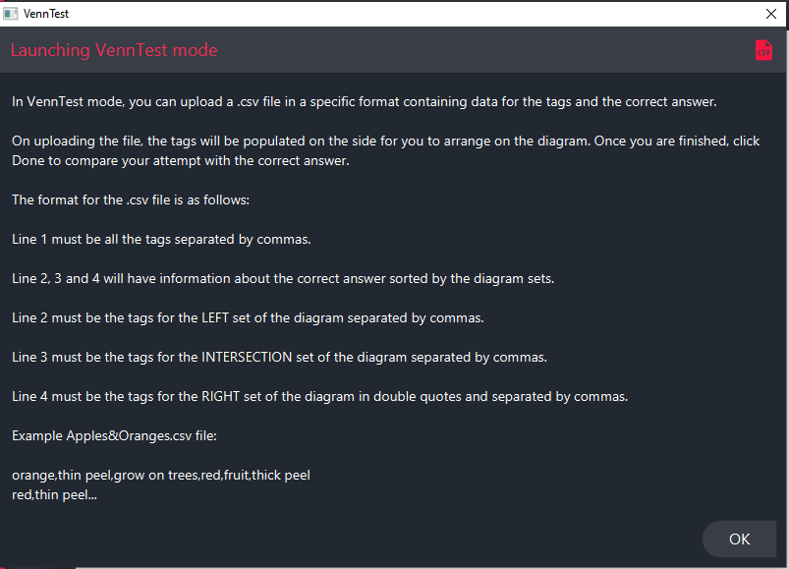The figure below demonstrates the visuals of the above steps

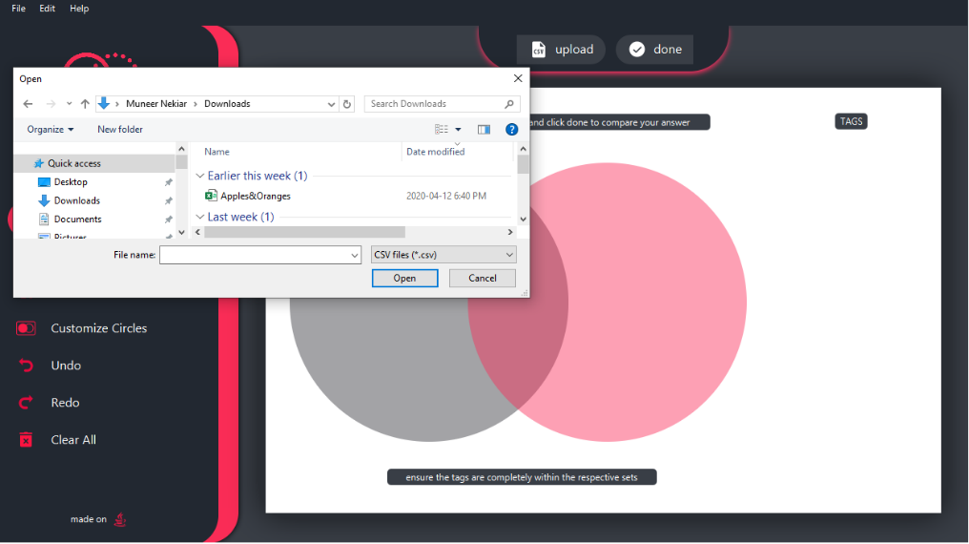

Figure

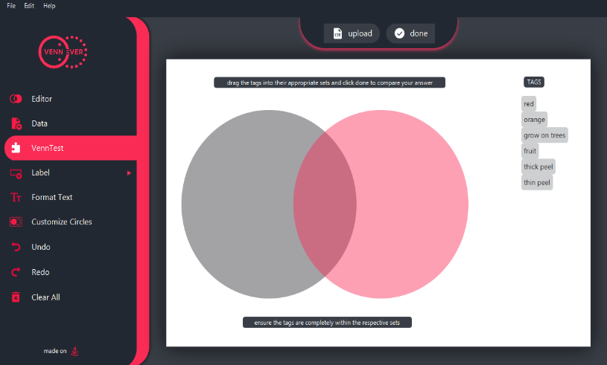

Figure

Figure : Apples&Oranges in the above figure is the example file available for you to use in order to understand the VennTest feature, it is available on the GitHub page.

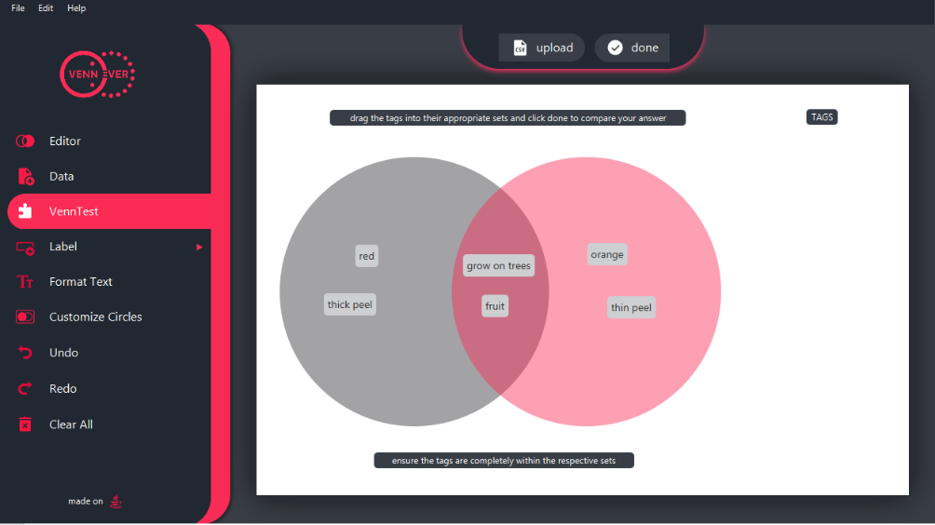

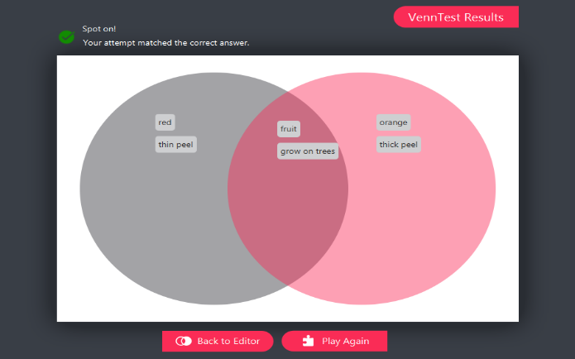

Figure

Figure

Figure

# Open/Save/Export:

* From the “file” menu click on “open” / “save” / “export” or alternatively “ctrl+O” / “ctrl+S” / ” ctrl+E” (“cmd+O” or“cmd+S” or “cmd+E” if using a mac) to open the file explorer
* Locate previously saved .venn file to open
* 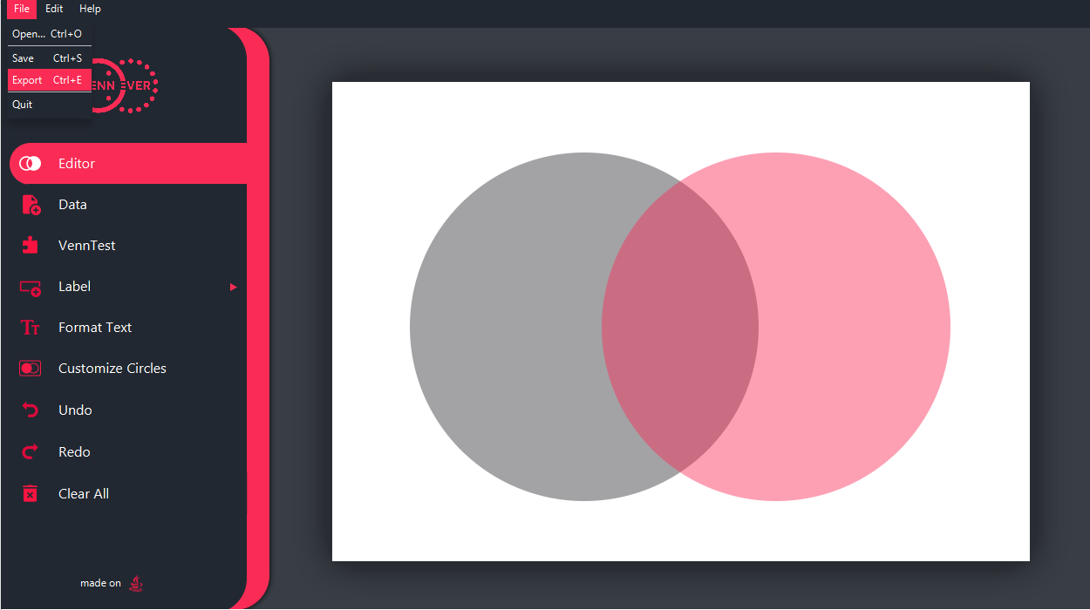Name your file and save/export it to your desired file location

Figure 26

# Help:

* For more help click om the “help” option from the top left menu bar
* Click on “About VennEver”
* This will open our GitHub page on your browser where you will find any additional information you may require

Figure 27

